1. Go to LPS GUI and click Local Service Availability

2. Select Basic Search and then Search by NPA/NXX/TN



3. Enter the NPA,NXX,Line and find the State and Ratecenter

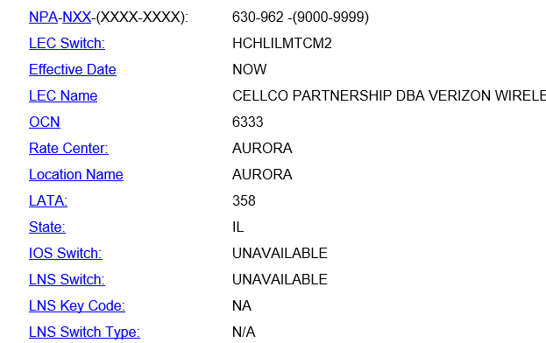

4. Again select Search by RateCenter and enter the State and Ratecenter

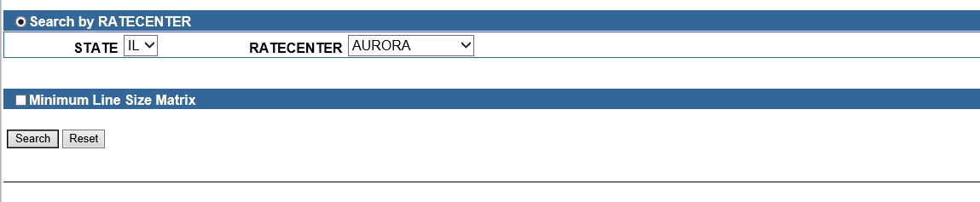

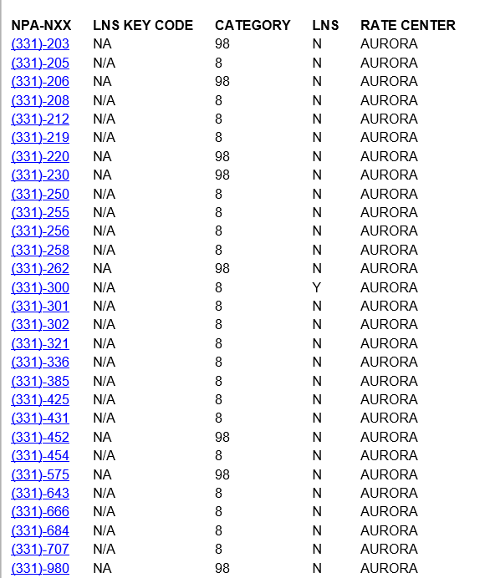

5. Select the TN Range which has the Cat as 8

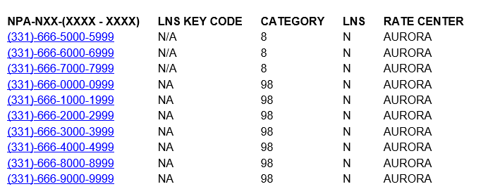

6. Select the fields from below query

SQL> select ocn,aocn,switch from lps_lerg13 where npa='331' and nxx='666' and linefr='5000' and lineto='5999';

OCN AOCN SWITCH

---- ---- -----------

224C 505B CHCGIL24DS6

7. Update the range in which that specific TN falls under and then update the user.

SQL> update lps_lerg13 set ocn='224C', aocn='505B',switch='CHCGIL24DS6' where NPA='630' and nxx='962' and LINEFR='9000' and LINETO='9999';

1 row updated.

SQL> commit;

Commit complete.

Note: The update will be rolled back every night based on the data feed.